**DAILY ONLINE ACTIVITIES SUMMARY**

|  |  |  |  |  |  |  |  |
| --- | --- | --- | --- | --- | --- | --- | --- |
| **Date:** | **16/06/2020** | | | | **Name:** | **Anusha. K** | |
| **Sem & Sec** | **4th SEM 'A' Section** | | | | **USN:** | **4AL18CS009** | |
| **Online Test Summary** | | | | | | | |
| **Subject** | | **Transform calculus, probability and statistical methods** | | | | | |
| **Max. Marks** | | **30** | | **Score** | | **24** | |
| **Certification Course Summary** | | | | | | | |
| **Course** | **Front end development- HTML** | | | | | | |
| **Certificate Provider** | | | **greatlearning academy** | **Duration** | | | **3.5hours** |
| **Coding Challenges** | | | | | | | |
| **Problem statement:write a c program to count the frequency of each element in an array.** | | | | | | | |
| **Status: completed** | | | | | | | |
| **Uploaded the report in Github** | | | | **yes** | | | |
| **If yes Repository name** | | | | [**https://github.com/anusha20219/Lockdown-coding**](https://github.com/anusha20219/Lockdown-coding) | | | |
| **Uploaded the report in slack** | | | | **yes** | | | |

ONLINE TEST DETAILS: maths test was conducted from 3.00 pm to 3.40 pm. There were 15 questions and time assigned was 40 minutes. The questions were mcq type. The portion was module 1.

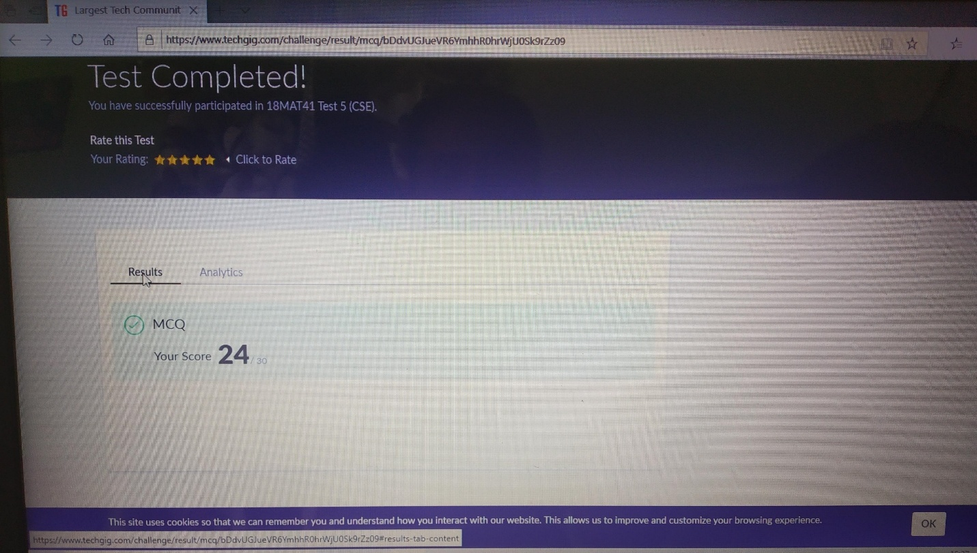

CERTIFICATION COURSE DETAILS: Today I completed front end development html which was fir 3.5 hrs and attend the quiz and got the certificate.

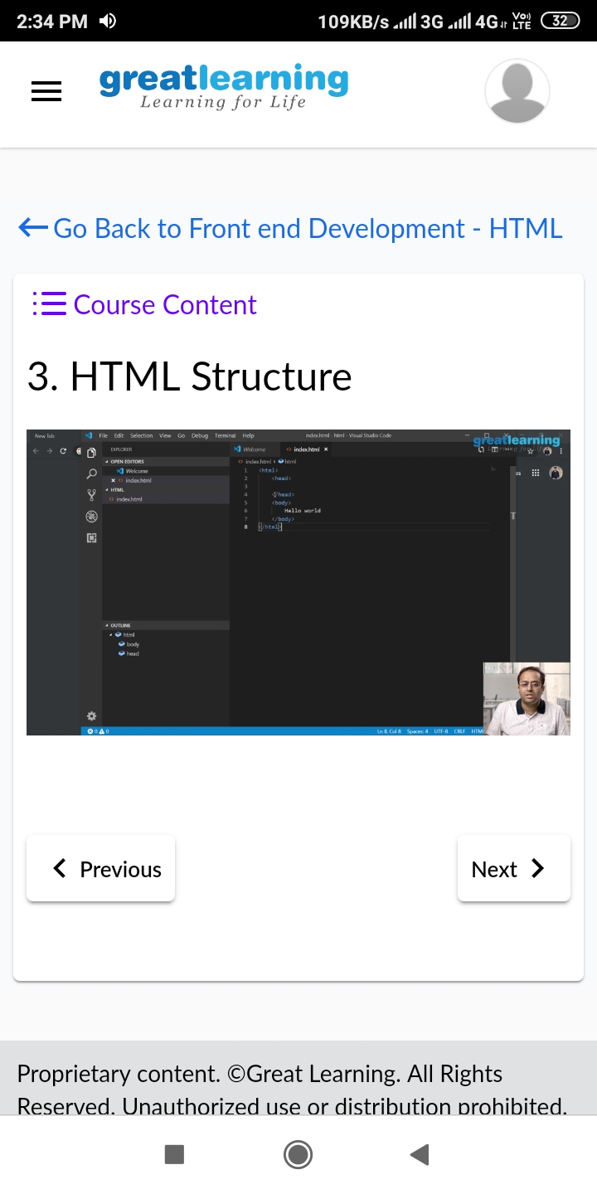

Coding challenge details:

Problem statement: write a c program to count the frequency of each element in an array.

